**AtoZ banking Application**

**Implemented the AtoZ Banking web application using Asp.net Core(3.1) MVC along with EntityFramework.**

**Tools: Visual Studio 2019, SQL Server Management Studio.**

**Database Changes:**

Created the Database and Tables as below

**Database Name:** AtoZBanking

**Tables :** Accounts and Transactions

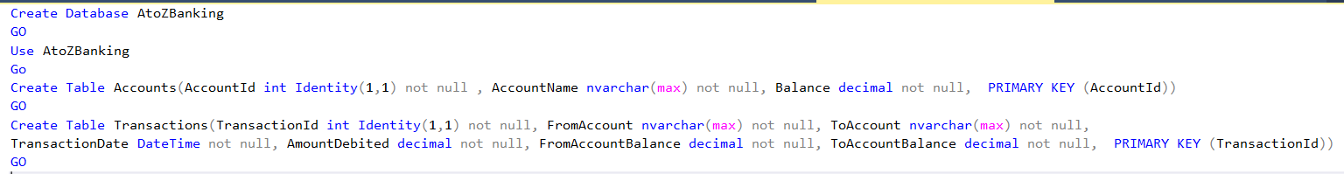

**UI Pages :**

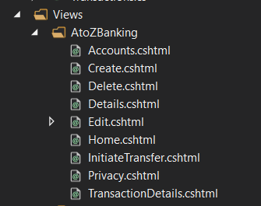

**Home.cshtml**

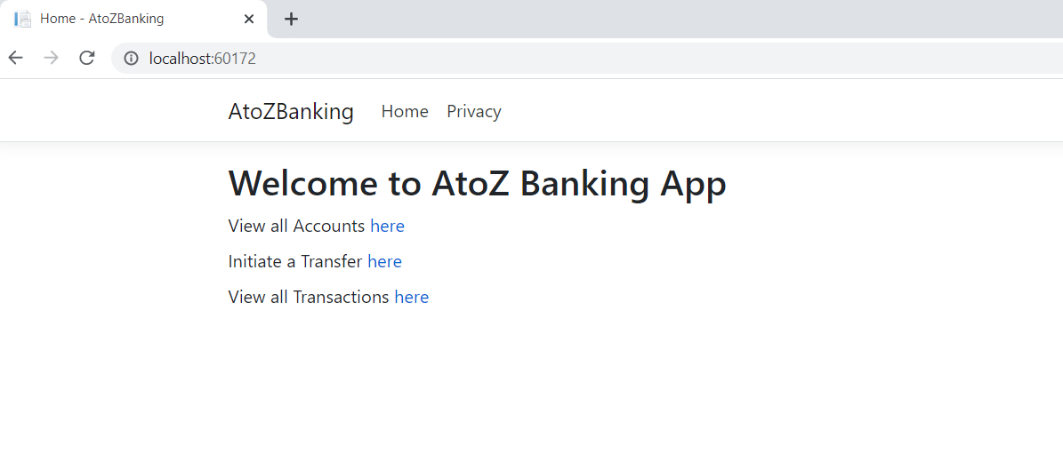

**Accounts.cshtml**

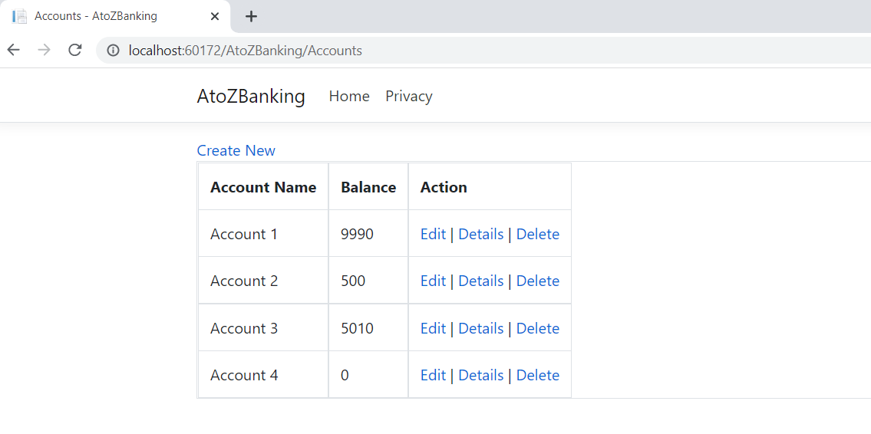

**Create.cshtml**

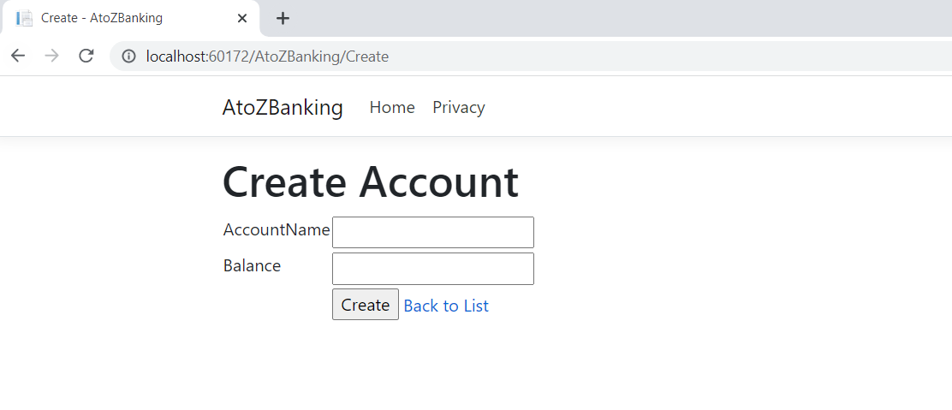

**Edit.cshtml**

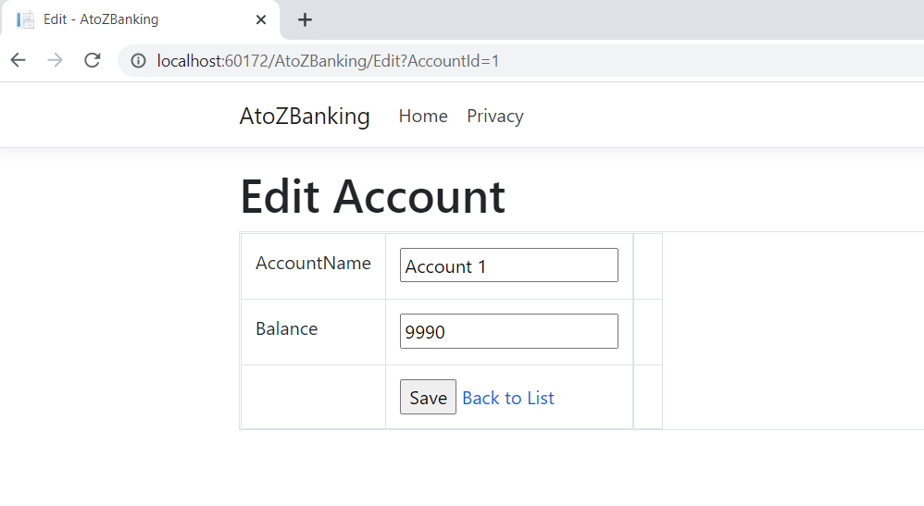

**Details.cshtml**

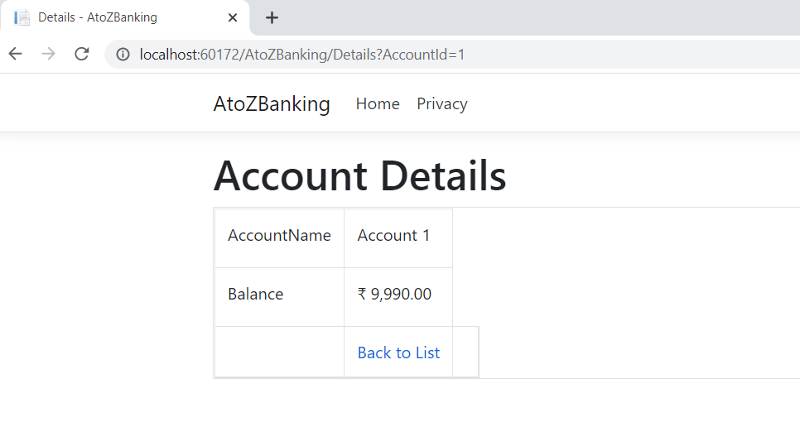

**Delete.cshtml**

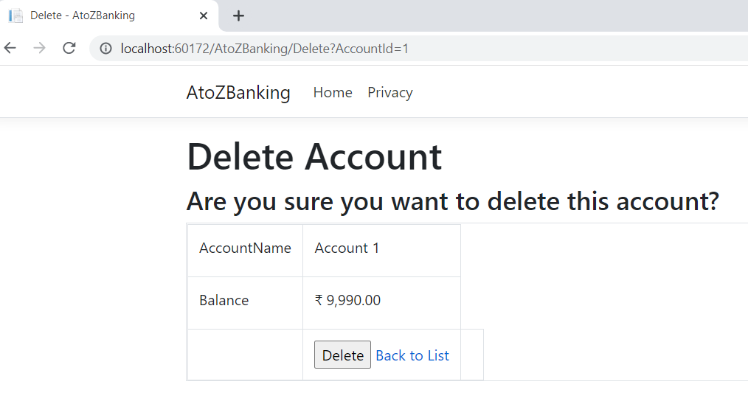

**InitiateTransfer.cshtml**

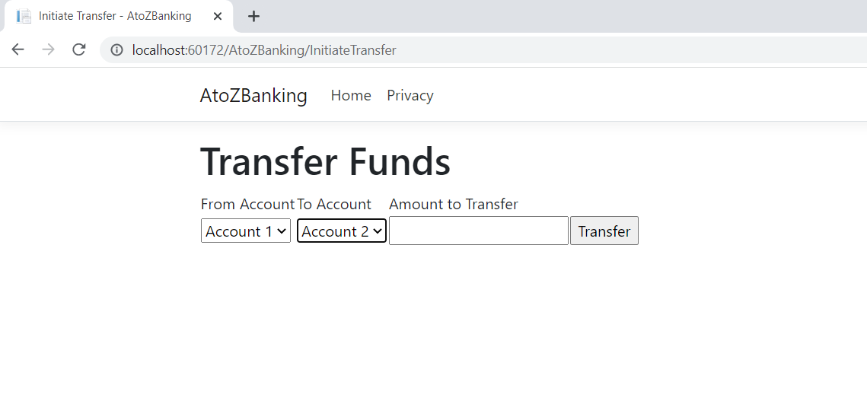

**TransactionDetails.cshtml**

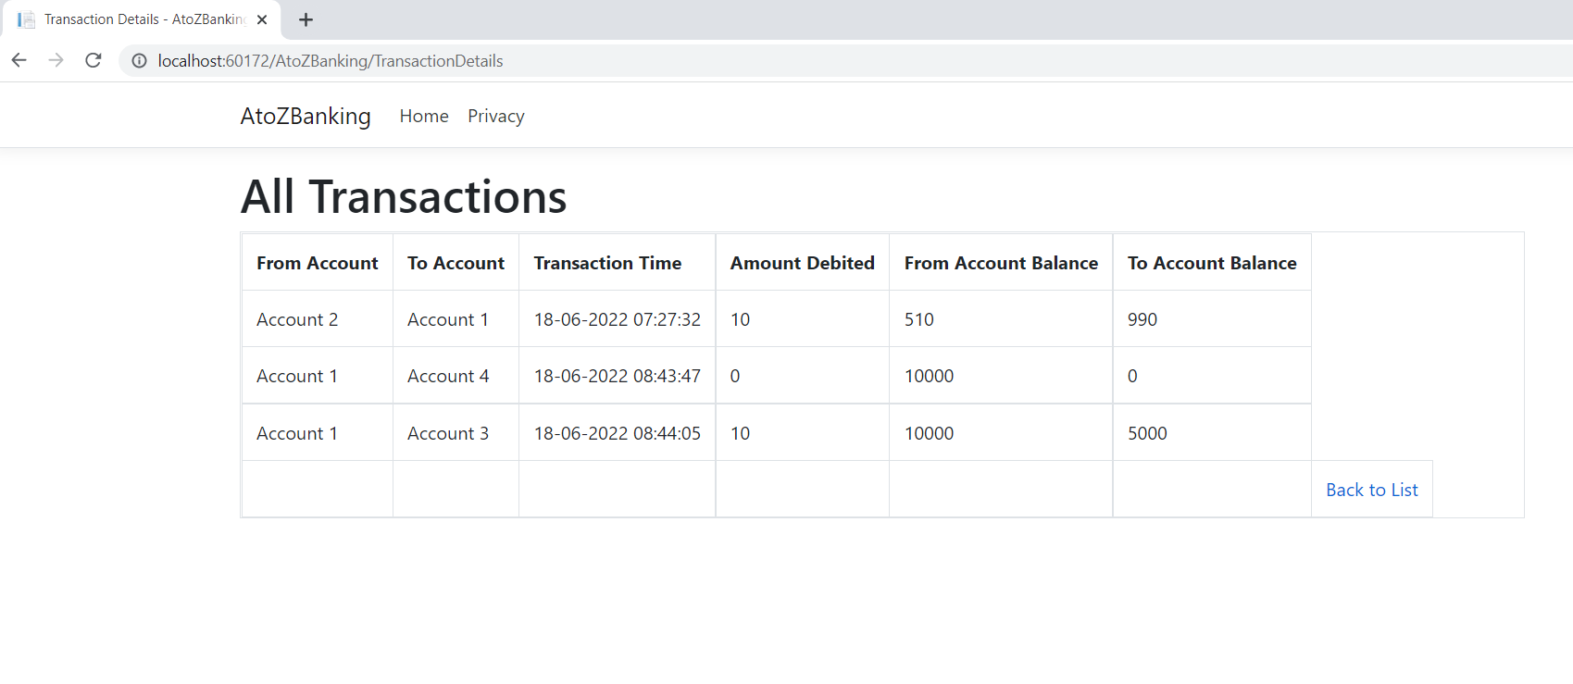

**Design and Development Steps of AtoZ Banking Application**

1. I have decided to implement the AtoZ Banking web application using **Asp.NetCore MVC** with Entityframework.
2. Created the **AtoZBanking** Database in SQLServer.
3. Created **Accounts** and **Transactions** Tables along with respective columns.

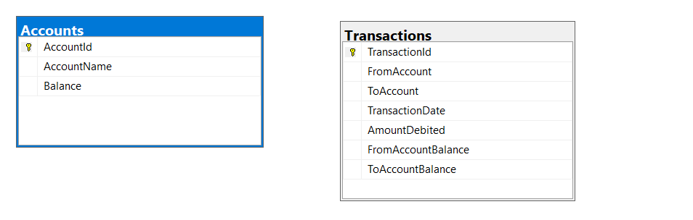

1. Created the new project (Asp.netCore MVC web application) using Visual Studio.
2. Installed the below packages from Manage Nuget Packages
3. Microsoft.EntityFrameworkCore.SqlServer
4. Microsoft.EntityFrameworkCore.Tools
5. Providing **ConnectionStrings** details in aoosettings.json file

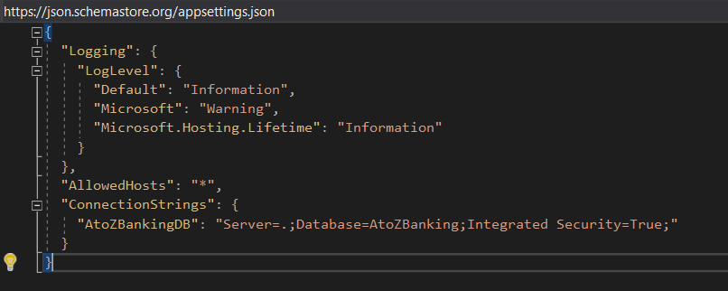

1. Creating the Models and DB Context.

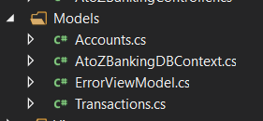

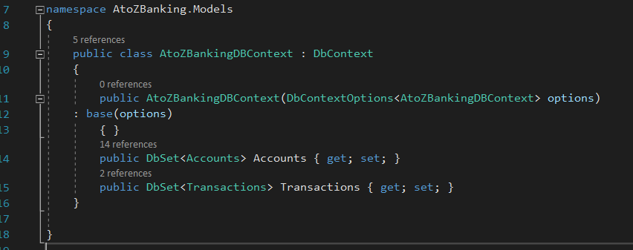

1. Configure Connection String in Startup.cs file.

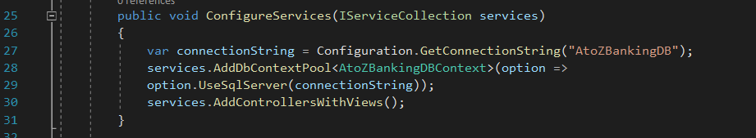

1. Creating the views(cshtml) files.

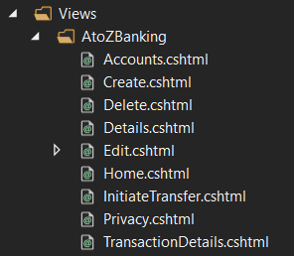

1. Creating the AtoZBanking Controller



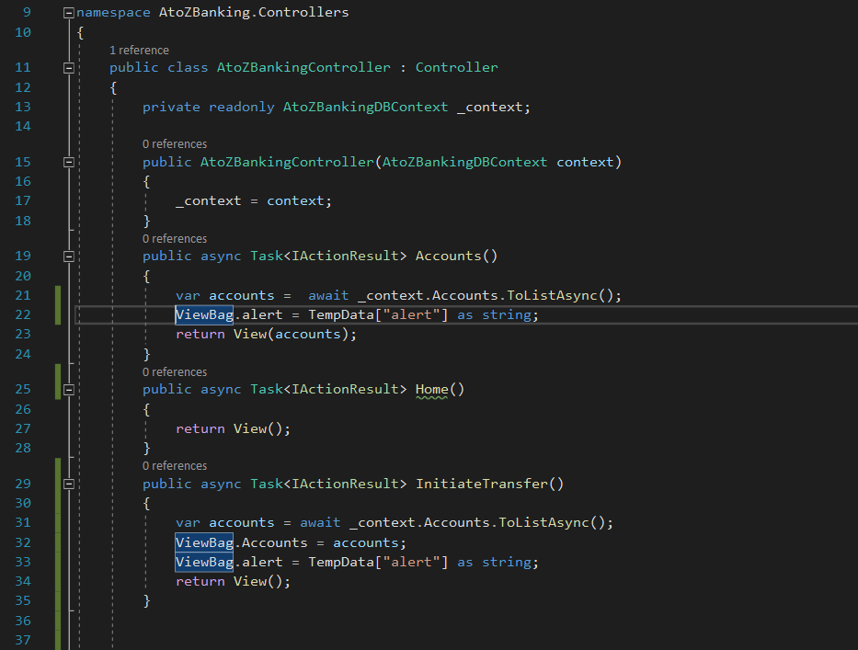

1. Set Default landing page as **Home.cshtml**

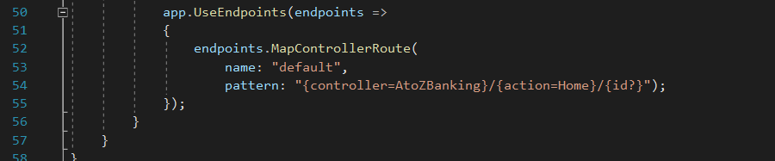

1. Code to get Account Details and Transaction Details

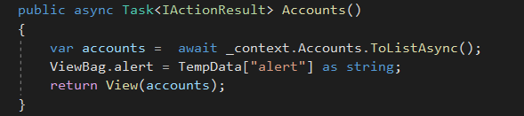

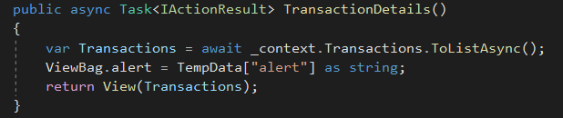

1. Code to Create, Edit and Delete functionality.

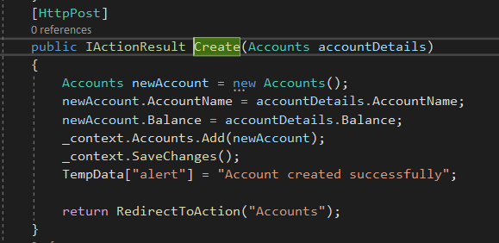

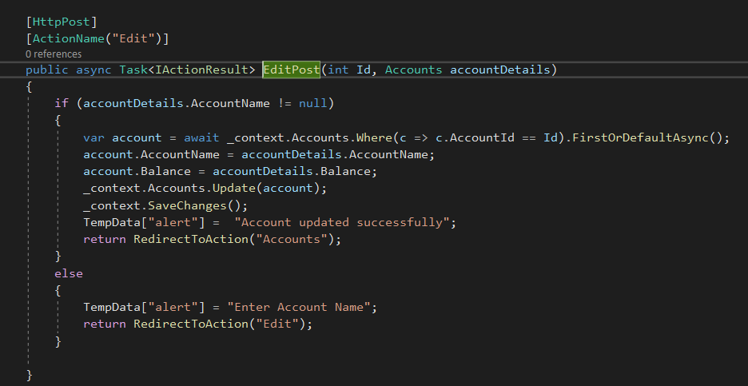

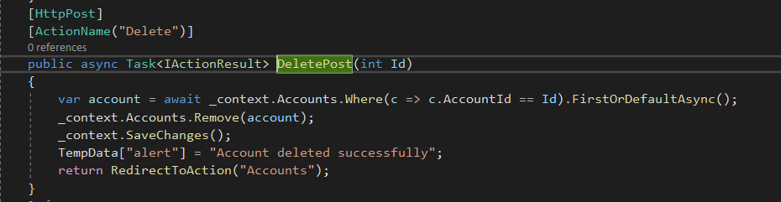

1. Code to Initiate Transfer fund

